**WAVEFORMS**

In [electronics](https://en.wikipedia.org/wiki/Electronics), [acoustics](https://en.wikipedia.org/wiki/Acoustics), and related fields, the **waveform** of a [signal](https://en.wikipedia.org/wiki/Signal) is the shape of its [graph](https://en.wikipedia.org/wiki/Graph_of_a_function) as a function of time, independent of its time and [magnitude](https://en.wikipedia.org/wiki/Magnitude_(mathematics)) [scales](https://en.wikipedia.org/wiki/Scale_(ratio)) and of any displacement in time **Periodic waveforms** are those that vary [periodically](https://en.wikipedia.org/wiki/Periodic_function) – they repeat regularly at consistent intervals.

In electronics, the term is usually applied to periodically varying [voltages](https://en.wikipedia.org/wiki/Voltage), [currents](https://en.wikipedia.org/wiki/Electric_current), or [electromagnetic fields](https://en.wikipedia.org/wiki/Electromagnetic_field). In acoustics, it is usually applied to steady periodic [sounds](https://en.wikipedia.org/wiki/Sound) — variations of [pressure](https://en.wikipedia.org/wiki/Air_pressure) in air or other media. In these cases, the waveform is an attribute that is independent of the [frequency](https://en.wikipedia.org/wiki/Frequency), [amplitude](https://en.wikipedia.org/wiki/Amplitude), or [phase shift](https://en.wikipedia.org/wiki/Phase_shift) of the signal. The term can also be used for non-periodic signals, like [chirps](https://en.wikipedia.org/wiki/Chirp) and [pulses](https://en.wikipedia.org/wiki/Pulse_(signal_processing)).

The waveform of an electrical signal can be visualized in an [oscilloscope](https://en.wikipedia.org/wiki/Oscilloscope) or any other device that can capture and plot its value at various times, with suitable [scales](https://en.wikipedia.org/wiki/Scale_(ratio)) in the time and value axes. The [electrocardiograph](https://en.wikipedia.org/wiki/Electrocardiography) is a [medical](https://en.wikipedia.org/wiki/Medicine) device to record the waveform of the electric signals that are associated with the beating of the [heart](https://en.wikipedia.org/wiki/Heart); that waveform has important [diagnostic](https://en.wikipedia.org/wiki/Diagnosis) value. [Waveform generators](https://en.wikipedia.org/wiki/Waveform_generator), that can output a periodic voltage or current with one of several waveforms, are a common tool in electronics laboratories and workshops.

The waveform of a steady periodic sound affects its [timbre](https://en.wikipedia.org/wiki/Timbre). [Synthesizers](https://en.wikipedia.org/wiki/Synthesizer) and modern [keyboards](https://en.wikipedia.org/wiki/Keyboard_(instrument)) can generate sounds with many complicated waveforms. 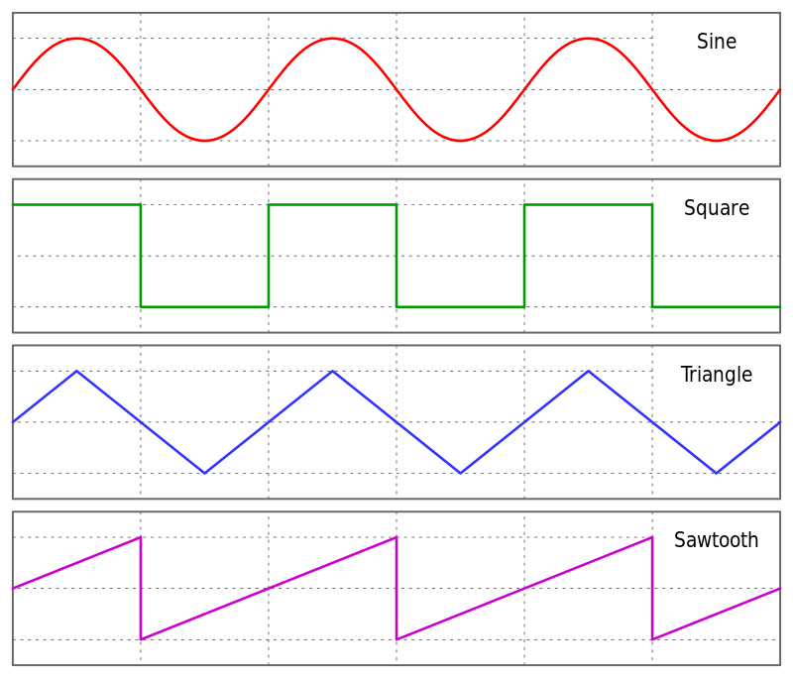

**Common periodic waveforms**

Simple examples of periodic waveforms include the following,

* [Sine wave](https://en.wikipedia.org/wiki/Sine_wave): (�,�,�,�)=�sin⁡2��−��The amplitude of the waveform follows a [trigonometric](https://en.wikipedia.org/wiki/Trigonometric) sine function with respect to time.
* [Square wave](https://en.wikipedia.org/wiki/Square_wave): (�,�,�,�)={�,(�−�)mod�<duty−�,otherwise. This waveform is commonly used to represent digital information. A square wave of constant [period](https://en.wikipedia.org/wiki/Frequency) contains odd [harmonics](https://en.wikipedia.org/wiki/Harmonic) that decrease at −6 dB/octave.
* [Triangle wave](https://en.wikipedia.org/wiki/Triangle_wave): (�,�,�,�)=2��arcsin⁡sin⁡2��−��. It contains odd [harmonics](https://en.wikipedia.org/wiki/Harmonic) that decrease at −12 dB/octave.
* [Sawtooth wave](https://en.wikipedia.org/wiki/Sawtooth_wave): (�,�,�,�)=2��arctan⁡tan⁡2��−�2�. This looks like the teeth of a saw. Found often in time bases for display scanning. It is used as the starting point for [subtractive synthesis](https://en.wikipedia.org/wiki/Subtractive_synthesis), as a sawtooth wave of constant [period](https://en.wikipedia.org/wiki/Frequency) contains odd and even [harmonics](https://en.wikipedia.org/wiki/Harmonic) that decrease at −6 [dB](https://en.wikipedia.org/wiki/Decibel)/octave.

The [Fourier series](https://en.wikipedia.org/wiki/Fourier_series) describes the decomposition of periodic waveforms, such that any periodic waveform can be formed by the sum of a (possibly infinite) set of fundamental and harmonic components. Finite-energy non-periodic waveforms can be analyzed into sinusoids by the [Fourier transform](https://en.wikipedia.org/wiki/Fourier_transform).

Other periodic waveforms are often called composite waveforms and can often be described as a combination of a number of sinusoidal waves or other [basis functions](https://en.wikipedia.org/wiki/Basis_functions) added together.

**Parameters of Periodic Wave Forms.**

Concepts like Peak Value (Amplitude), Average Value, RMS Value, Form Factor, and Peak Factor are some of these Parameters of Periodic Wave Forms.

***Peak Value (Amplitude)*** It is the maximum value of the wave during either positive or negative half cycle. Here Vm is the peak value

***Average Value***

The average value of a periodic function x(t) can be represented as

xav = 1 T ∫ x(t) T 0 dt

Where T is the period of the function. Ex: In case of sinusoidal wave, the average value can be represented as

Vav = 1 π ∫ Vm π 0 sinωtd(ωt) = 1 π [−Vmcosωt]0 π = 2Vm π

Here the average value of sinusoidal voltage wave is computed for half cycle as the average value of the sine wave for full cycle would be zero.

***RMS value (Root Mean Square Value)*** As the effective value of a sine wave is zero for the entire cycle hence in order to get the effective value, we compute the capability of the sine wave in terms of heating power. This is represented by the root mean square value, and also known effective value. It can be represented by xrms = √ 1 T ∫ [x(t)] 2 T 0 dt Where T is the period of the function For a sinusoidal voltage wave Vrms = √ 1 2π ∫ (Vmsinωt) 2 2π 0 d(ωt) = √ 1 2π ∫ Vm 2 2π 0 [ 1−cos2ωt 2 ] d(ωt

***Form Factor*** It is defined by the ratio of RMS and average values. The form Factor of a sinusoidal voltage wave is given by Form Factor (FF) = Vrms Vav = Vm √2 2Vm π = π 2√2 = 1.11

It is defined by the ratio of maximum value and RMS values for sinusoidal voltage wave. Peak factor = Vmax VRms = Vm Vm √2 = √2

# **SIGNALS AND SYSTEMS**

https://www.youtube.com/watch?v=SOASwKMsDXw

**SIGNAL SOURCES**

A signal source is an electronic instrument which generates a signal according to the user s commands respecting its waveform. Signal sources serve the frequent need in engineering and scientific work for energizing a circuit or system with a signal whose characteristics are known

## Systems

A **System** is any physical set of components or a function of several devices that takes a signal in as input, and produces a signal as output.

A system is a defined by the type of input and output it deals with. Since we are dealing with signals, so in our case, our system would be a mathematical model, a piece of code/software, or a physical device, or a black box whose input is a signal and it performs some processing on that signal, and the output is a signal. The input is known as excitation and the output is known as response.

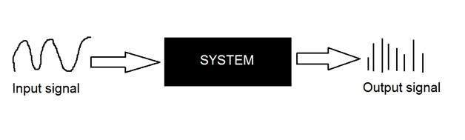

In the above figure a system has been shown whose input and output both are signals but the input is an analog signal. And the output is a digital signal. It means our system is actually a conversion system that converts analog signals to digital signals.

## *Conversion of analog to digital signals*

Since there are lot of concepts related to this analog to digital conversion and vice-versa. We will only discuss those which are related to digital image processing. There are two main concepts that are involved in the conversion.

* Sampling
* Quantization

### **Sampling**

Sampling as its name suggests can be defined as take samples. Take samples of a digital signal over x axis. Sampling is done on an independent variable. In case of this mathematical equation:

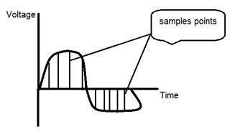

Sampling is done on the x variable. We can also say that the conversion of x axis (infinite values) to digital is done under sampling.

Sampling is further divide into up sampling and down sampling. If the range of values on x-axis are less then we will increase the sample of values. This is known as up sampling and its vice versa is known as down sampling.

### **Quantization**

Quantization as its name suggest can be defined as dividing into quanta (partitions). Quantization is done on dependent variable. It is opposite to sampling.

In case of this mathematical equation y = sin(x)

Quantization is done on the Y variable. It is done on the y axis. The conversion of y axis infinite values to 1, 0, -1 (or any other level) is known as Quantization.

These are the two basics steps that are involved while converting an analog signal to a digital signal.

The quantization of a signal has been shown in the figure below.

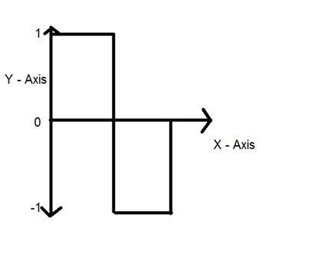

## Why do we need to convert an analog signal to digital signal.

The first and obvious reason is that digital image processing deals with digital images, that are digital signals. So when ever the image is captured, it is converted into digital format and then it is processed.

The second and important reason is, that in order to perform operations on an analog signal with a digital computer, you have to store that analog signal in the computer. And in order to store an analog signal, infinite memory is required to store it. And since thats not possible, so thats why we convert that signal into digital format and then store it in digital computer and then performs operations on it.

## Continuous systems vs discrete systems

### **Continuous systems**

The type of systems whose input and output both are continuous signals or analog signals are called continuous systems.

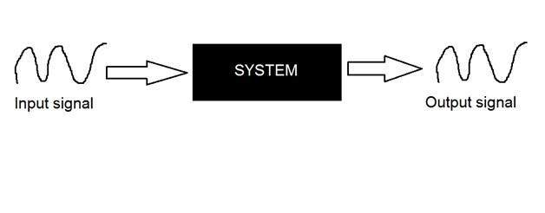

### **Discrete systems**

The type of systems whose input and output both are discrete signals or digital signals are called digital systems.

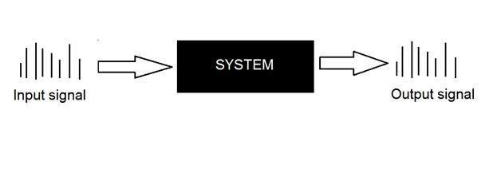

**Properties of systems:**

1. Periodicity- the signal’s behavior/graph repeats after every T. Therefore,

$$x(t)=x(t+nT)\ or\ x(t)=x(t-nT)$$

here T is the fundamental period

So we can say signal remains unchanged when shifted by multiples of T.

1. Even and Odd- an even signal is symmetric about the Y-axis.

x(t)=x(-t) even

x(t)=-x(-t) odd

A signal can be broken into it’s even and odd parts to make certain conversions easy.

$$Even(x(t)) = (x(t)+x(-t))/2$$ $$Odd(x(t)) = (x(t)-x(-t))/2$$

3. Linearity- constitutes of two properties-

(i) Additivity/Superposition-

if x1(t) -> y1(t)

and x2(t) -> y2(t)

$$x1(t) + x2(t)\ \rightarrow y1(t) + y2(t)$$

(ii) Property of scaling-

if x1(t) -> y1(t)

then

$$a*x1(t)\ \rightarrow a*y1(t)$$

If both are satisfied, the system is linear.

1. Time invariant- Any delay provided in the input must be reflected in the output for a time invariant system.

$$ take \ x2(t)=x(t-T)$$ $$ then\ y(x2(t))\ must\ be\ =x2(y(t))$$

here x2(t) is a delayed input.

We check if putting a delayed input through the system is the same as a delay in the output signal.

1. LTI systems- A linear time invariant system. A system that is linear and time-invariant.
2. BIBO stability- The bounded input bounded output stability. We say a system is BIBO stable if-

$$\int_{-\infty}^{\infty} |x(t)| dt\ < \infty$$

1. Causality- Causal signals are signals that are zero for all negative time.

If any value of the output signal depends on a future value of the input signal then the signal is non-causal.

1. Reflection : If a signal is given by x(t) then the reflected signal is described by x(-t). Thus, the reflected signal assumes at time –t the value of the original signal that occurs at time t.

## What is baseband?

Baseband in the transmission of communications signals means only one path is available to send and receive digital signals between devices. Baseband communication systems have been in use for many years and is still used in technologies such as [Ethernet](https://www.techtarget.com/searchnetworking/definition/Ethernet) and [wireless communications](https://www.techtarget.com/searchmobilecomputing/definition/wireless).

Baseband technology is used in several ways:

* Information is carried in digital form on a single signal channel that isn't [multiplexed](https://www.techtarget.com/searchnetworking/definition/multiplexing) and uses a transmission medium, such as copper [twisted-pair](https://www.techtarget.com/searchdatacenter/definition/Categories-of-twisted-pair-cabling-systems) wires. Baseband network technology is used in various types of networks, including Ethernet and [token ring](https://www.techtarget.com/searchnetworking/definition/Token-Ring) local area networks.
* With multiplexing, a transmission channel derives additional paths over a baseband channel.
* A baseband signal transmits data streams as analog signals using [modulation](https://www.techtarget.com/searchnetworking/definition/modulation) technology.
* With any frequency [band](https://www.techtarget.com/searchnetworking/definition/band) on which information is superimposed, baseband can be used whether or not the band is multiplexed and information is sent on subbands. In this application, it's assumed that the carrier frequency band used isn't shifted to a different frequency band but remains at its original place in the electromagnetic spectrum.

## *10BASE-T and its derivatives*

Baseband technology is used in Ethernet networks. Ethernet is typically deployed in a [star network](https://www.techtarget.com/searchnetworking/definition/star-network) configuration with the network hub and device connections radiating from the hub. The Institute of Electrical and Electronics Engineers ([IEEE](https://www.techtarget.com/whatis/definition/IEEE-Institute-of-Electrical-and-Electronics-Engineers)) defines current Ethernet transmission specifications as follows:

* **10BASE-T.** The initial IEEE Ethernet standard, 10BASE-T provides 10 megabits per second (Mbps) of transmission [bandwidth](https://www.techtarget.com/searchnetworking/definition/bandwidth) over a baseband channel using twisted-pair copper wiring.
* **100BASE-T.** This standard supports transmission speeds up to 100 Mbps.
* **1000BASE-T.** The [1000BASE-T](https://www.techtarget.com/searchnetworking/definition/1000BASE-T) standard supports transmission speeds up to 1,000 Mbps or 1 gigabit per second (Gbps). It is also referred to as [Gigabit Ethernet](https://www.techtarget.com/searchnetworking/definition/Gigabit-Ethernet).
* **10GBASE-T.** The 10GBASE-T standard supports transmission speeds up to 10 Gbps.

In addition to twisted-pair copper cable, providers use [coaxial cable](https://www.techtarget.com/searchnetworking/definition/coaxial-cable-illustrated) and [fiber optic](https://www.techtarget.com/searchnetworking/definition/fiber-optics-optical-fiber) cable as transmission media. The following are IEEE standards for each of these media:

* **10BASE-2.** This standard is for thin-wire coaxial cable with a maximum transmission distance of 607 feet, or 185 meters.
* **10BASE-5.** This is the thick-wire coaxial cable standard with a maximum transmission distance of 1,640 feet, or 500 meters.
* **10BASE-F.** This is the standard for fiber optic transmission cables.
* **10BASE-36**. The standard for broadband coaxial cable that supports transmission of multiple baseband channels over a maximum distance of 11,800 feet, or 3,600 meters.

## Baseband vs. broadband

A [broadband](https://www.techtarget.com/searchnetworking/definition/broadband) transmission and signal processing system supports multiple frequency bands, whereas baseband transmission uses only one transmission band. Both telecommunications technologies support multiple concurrent transmissions, but they use different equipment at each end to accommodate different signal transmission methods.

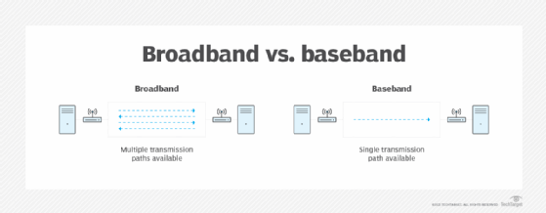

## Strengths and limitations of baseband

Baseband is a cost-effective technology that's easy to use and inexpensive to install using twisted pair cable. It's also simple to maintain, and its simple structure makes it easy to understand and work with.

However, baseband can only be used for voice and data communications. It isn't generally used for video, and it has a [limited transmission range](https://www.tutorialspoint.com/what-is-baseband-transmission-in-computer-networks).

# **Modulation communications**

**Modulation**, in [electronics](https://www.britannica.com/technology/electronics), technique for impressing information (voice, music, pictures, or data) on a [radio](https://www.britannica.com/technology/radio-technology)-frequency [carrier wave](https://www.britannica.com/technology/carrier-wave) by varying one or more characteristics of the wave in accordance with the information signal. There are various forms of modulation, each designed to alter a particular characteristic of the carrier wave. The most commonly altered characteristics include amplitude, frequency, phase, pulse sequence, and [pulse duration](https://www.britannica.com/technology/pulse-duration-modulation).

## *Analog modulation*

The following techniques—amplitude modulation, frequency modulation, and phase modulation—are [analog](https://www.merriam-webster.com/dictionary/analog) modulation techniques. That is, they work by modulating a continuous carrier wave, rather than a signal encoded in [binary](https://www.britannica.com/technology/binary-code) digits as with digital techniques.

## *Amplitude modulation*

In [amplitude modulation](https://www.britannica.com/technology/amplitude-modulation) (AM), auditory or visual information is impressed on a carrier wave by varying the amplitude of the carrier to match the fluctuations in the audio or video signal being transmitted. AM is the oldest method of [broadcasting](https://www.britannica.com/technology/broadcasting) [radio](https://www.britannica.com/topic/radio) programs. Commercial AM stations operate at frequencies spaced 10 kHz apart between 540 and 1,700 kHz. Radio waves in this frequency range are effectively reflected back to Earth’s surface by the [ionosphere](https://www.britannica.com/science/ionosphere-and-magnetosphere) and can be detected by receivers hundreds of kilometres away. In addition to its use in commercial radio broadcasting, AM is employed in long-distance [shortwave radio](https://www.britannica.com/technology/shortwave-radio) broadcasts and in [transmitting](https://www.britannica.com/dictionary/transmitting) the video portion of [television](https://www.britannica.com/technology/television-technology) programs.

## *Frequency*[*modulation*](https://www.britannica.com/technology/amplitude-modulation)

In [frequency modulation](https://www.britannica.com/technology/frequency-modulation) (FM), unlike AM, the amplitude of the carrier is kept constant, but its frequency is altered in accordance with variations in the audio signal being sent. This form of modulation was developed by the American electrical engineer [Edwin H. Armstrong](https://www.britannica.com/biography/Edwin-H-Armstrong) during the early 1930s in an effort to overcome interference and noise that affect AM radio reception. FM is less susceptible than AM to certain kinds of interference, such as that caused by thunderstorms and by random electrical currents from machinery and other related sources. These noise-producing signals affect the amplitude of a [radio wave](https://www.britannica.com/science/radio-wave) but not its frequency, and so an FM signal remains virtually unchanged.

FM is better adapted than AM to the [transmission](https://www.britannica.com/dictionary/transmission) of stereophonic sound, audio signals for television programs, and long-distance [telephone](https://www.britannica.com/technology/telephone) calls by microwave radio relay. Commercial FM broadcasting stations are assigned higher frequencies than are AM stations. The assigned frequencies, spaced 200 kHz apart, range from 88 to 108 MHz.

## *Phase modulation*

The phase of a carrier wave is varied in response to the vibrations of the sound source in phase modulation (PM). This form of modulation is often considered a variation of FM. The two processes are closely related, because phase cannot be changed without also varying frequency and vice versa. Also, the rate at which the phase of a carrier changes is directly proportional to the frequency of the audio signal.

Like FM, PM minimizes various types of interference to broadcast reception at frequencies below 30 MHz. The two techniques are commonly used together. FM cannot be applied during the amplification of a sound signal in broadcasting, and so PM is used instead. PM is also used in some [microwave](https://www.britannica.com/science/microwave-radiation) radio relays and in some [Wi-Fi](https://www.britannica.com/technology/Wi-Fi) and satellite television systems.

## *Digital modulation*

In order to transmit [computer](https://www.britannica.com/technology/computer) data and other digitized information over a communications channel, an analog carrier wave can be modulated to reflect the binary nature of the digital baseband signal. The [parameters](https://www.merriam-webster.com/dictionary/parameters) of the carrier that can be modified are the amplitude, the frequency, and the phase.

## *Amplitude-shift keying*

If amplitude is the only [parameter](https://www.merriam-webster.com/dictionary/parameter) of the carrier wave to be altered by the information signal, the modulating method is called amplitude-shift keying (ASK). ASK can be considered a digital version of analog amplitude modulation. In its simplest form, a burst of radio frequency is transmitted only when a binary 1 appears and is stopped when a 0 appears. In another variation, the 0 and 1 are represented in the modulated signal by a shift between two preselected amplitudes.

## *Frequency-shift keying*

If frequency is the parameter chosen to be a function of the information signal, the modulation method is called frequency-shift keying (FSK). In the simplest form of FSK signaling, digital [data](https://www.britannica.com/dictionary/data) is transmitted using one of two frequencies, whereby one frequency is used to transmit a 1 and the other frequency to transmit a 0.

## *Phase-shift keying*

When phase is the parameter altered by the information signal, the method is called phase-shift keying (PSK). In the simplest form of PSK, a single radio frequency carrier is sent with a fixed phase to represent a 0 and with a 180° phase shift—that is, with the opposite polarity—to represent a 1.

In addition to the elementary forms of digital modulation described above, there exist more-advanced methods that result from a superposition of multiple modulating signals. An example of the latter form of modulation is quadrature [amplitude](https://www.britannica.com/dictionary/amplitude) modulation (QAM). QAM signals actually transmit two amplitude-modulated signals in phase quadrature (i.e., 90° apart), so that four or more bits are represented by each shift of the combined signal.

## [*Pulse modulation*](https://www.britannica.com/technology/pulse-coded-modulation)

In pulse modulation, a series of on-off pulses serve as the carrier wave that is subsequently modulated. In pulse-coded modulation (PCM), the information signal converts the carrier into a series of constant-amplitude pulses spaced in such a manner that the desired intelligence is contained in coded form. PCM minimizes transmission losses and eliminates noise and interference problems because the receiving unit need only detect and identify simple pulse patterns. PCM is used for digital audio in computers and in [compact discs](https://www.britannica.com/technology/compact-disc), [DVDs](https://www.britannica.com/technology/DVD), and [Blu-Ray](https://www.britannica.com/technology/Blu-ray) discs. Another kind of pulse modulation is pulse-duration modulation (PDM), in which intelligence is represented by the length and order of regularly recurring pulses.

# ***Amplitude modulation***

**Amplitude modulation (AM)**, variation of the [amplitude](https://www.britannica.com/science/amplitude-physics) of a [carrier wave](https://www.britannica.com/technology/carrier-wave) (commonly a [radio](https://www.britannica.com/topic/radio) wave) in accordance with the [characteristics](https://www.britannica.com/dictionary/characteristics) of a signal, such as a vocal or [musical sound](https://www.britannica.com/science/musical-sound) composed of audio-frequency waves. See [modulation](https://www.britannica.com/technology/modulation-communications).

# ***Data transmission***

**Data transmission**, sending and receiving [data](https://www.britannica.com/dictionary/data) via cables (e.g., [telephone](https://www.britannica.com/technology/telephone) lines or [fibre optics](https://www.britannica.com/science/fiber-optics)) or wireless systems.

Because ordinary telephone circuits pass signals that fall within the frequency range of voice [communication](https://www.britannica.com/topic/communication) (about 300–3,500 hertz), the high frequencies associated with data transmission suffer a loss of amplitude and transmission speed. Data signals must therefore be translated into a format compatible with the signals used in telephone lines. [Digital computers](https://www.britannica.com/technology/digital-computer) use a [modem](https://www.britannica.com/technology/modem) to transform outgoing digital electronic data, and a similar system at the receiving end translates the incoming signal back to the original electronic data.

For data transmission over cable lines, which can transfer data at a much higher rate than that of ordinary telephone [circuits](https://www.britannica.com/dictionary/circuits), a cable modem is used that modulates and demodulates signals like a telephone modem but is a much more complex device. Once data have arrived at the modem in a home or business, they are often transmitted wirelessly from a router to other devices, such as [personal computers](https://www.britannica.com/technology/personal-computer) or [televisions](https://www.britannica.com/technology/television-technology).

Portable devices such as [smartphones](https://www.britannica.com/technology/smartphone) and [tablet computers](https://www.britannica.com/technology/tablet-computer) receive data wirelessly, either over the networks used for cellular phones or over short-range networks using [Wi-Fi](https://www.britannica.com/technology/Wi-Fi). See also [broadband technology](https://www.britannica.com/technology/broadband-technology); [cable modem](https://www.britannica.com/technology/cable-modem); [DSL](https://www.britannica.com/technology/DSL); [ISDN](https://www.britannica.com/technology/ISDN); [fax](https://www.britannica.com/technology/fax); [radio](https://www.britannica.com/technology/radio-technology); [teletype](https://www.britannica.com/technology/teleprinter); [T1](https://www.britannica.com/technology/T1); [wireless communications](https://www.britannica.com/technology/wireless-communications).

# ***Multiplexing***

**Multiplexing**, [simultaneous](https://www.britannica.com/dictionary/simultaneous) electronic transmission of two or more messages in one or both directions over a single transmission path, with signals separated in time or frequency. In [time-division multiplexing](https://www.britannica.com/technology/time-division-multiplexing), different time intervals are employed for different signals. Two or more different signals may be transmitted in time sequence: the instantaneous amplitude of each signal is sampled and transmitted in sequence. When all signals have been sampled, the process is repeated. The sampling process is carried out rapidly enough to avoid loss of essential information in the signal.

In [frequency-division multiplexing](https://www.britannica.com/technology/frequency-division-multiplexing), each message is identified with a separate subcarrier frequency; all of these subcarriers are then combined to modulate the carrier frequency. For wire transmission, the modulated subcarriers may be [transmitted](https://www.britannica.com/dictionary/transmitted) directly without the introduction of a carrier frequency.

The subcarriers are separated at the receiver terminal by frequency selection and the original message signal recovered from the subcarrier.

# ***Frequency modulation***

**Frequency modulation**, (FM), variation of the frequency of a [carrier wave](https://www.britannica.com/technology/carrier-wave) in accordance with the [characteristics](https://www.britannica.com/dictionary/characteristics) of a signal. See [modulation](https://www.britannica.com/technology/modulation-communications).

# ***Carrier wave***

**Carrier wave**, in electronics, the unmodulated single-frequency [electromagnetic wave](https://www.britannica.com/science/electromagnetic-radiation) that carries the desired information—i.e., is modulated by the information. See [modulation](https://www.britannica.com/technology/modulation-communications) (electronics).